Ideation Phase
Brainstorm & Idea Prioritization Template

Date | 30 September 2026
Team ID | SWTID-2026-1437
Project Name | AI WeatherWise API
Maximum Marks | 4 Marks

Brainstorm & Idea Prioritization Template:
Brainstorming provides a free and open environment that encourages everyone within a team to participate in the creative thinking process that leads to problem solving. Prioritizing volume over value, out-of-the-box ideas are welcome and built upon, and all participants are encouraged to collaborate, helping each other develop a rich amount of creative solutions.
Use this template in your own brainstorming sessions so your team can unleash their imagination and start shaping concepts even if you're not sitting in the same room.
Reference: https://www.mural.co/templates/brainstorm-and-idea-prioritization
Step-1: Team Gathering, Collaboration and Select the Problem Statement
Team ID: SWTID-2026-1437 | Project: AI WeatherWise API
The team gathered to discuss everyday weather problems and how technology can help. Selected problem statement: people find it hard to get quick, reliable weather information with clear guidance, and developers find it hard to combine authentication, weather data and AI in one service.

Step-2: Brainstorm, Idea Listing and Grouping
Authentication | Weather | AI Insights | Quality & Extras
User registration  User login  JWT-protected routes  User profile | Weather by city  Current temperature and conditions  Invalid city handling  Weather API integration | AI weather summary  Clothing / travel suggestions  Safety tips for extreme weather | Input validation  Error handling  API response validation  Saved favourite cities  Weather alerts

Step-3: Idea Prioritization
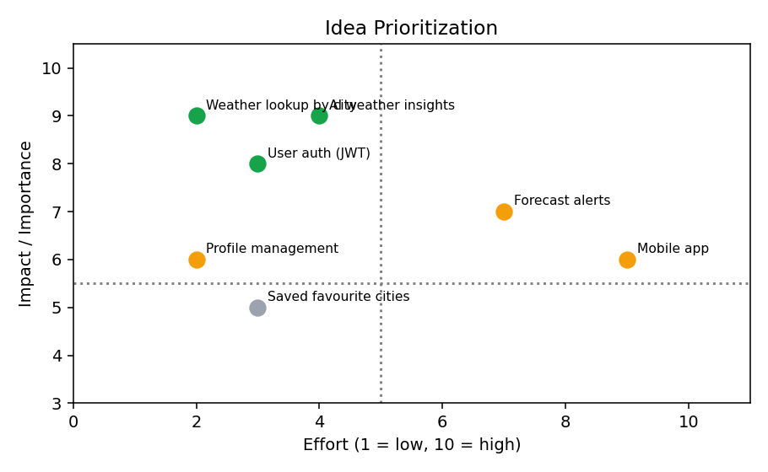
Priority | Idea | Reason
High | Weather lookup by city; User auth (JWT); AI weather insights | High impact and core to the project with reasonable effort
Medium | Profile management; Saved favourite cities | Useful but not essential for the first version
Low | Forecast alerts; Mobile app | Higher effort; planned for future versions

